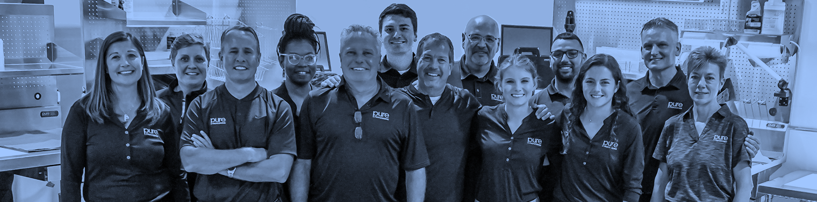

NOW HIRING

NOW HIRING: Service Manager

Who we Are
Pure Processing, LLC was founded with the mission to make surgical instrument cleaning faster, safer, and more ergonomic for
one of the most important departments in the whole hospital: sterile processing. By engineering & manufacturing equipment to support these objectives, we help hospitals deliver on the most sacred clinical promise: optimal patient safety & care.

Who You Are
You'll be a great fit if you:

- Enjoy building and creating; like showing off mastery of your craft by demonstrating quality of your work
- Seek a small, high-growth company where you can be part of a team but still have independent, autonomous work
- Are mechanically inclined, and like the challenge of solving or fixing problems
- Like helping others and are interested in the healthcare space; installing equipment at hospitals would be exciting to you!

Job Description
The Service Manager’s core functions involve assembling, installing, quality control testing, servicing, shipping, receiving, and maintenance of the full Pure Processing catalog.

The Service Manager will also be responsible for traveling to medical facilities to install, service, troubleshoot, or maintenance Pure Processing products as required.
Travel: Light travel required, up to 15%

Job Responsibilities
- Assembly of Pure Processing products, including but not limited to: creating pallets, mounting accessories, wiring and channeling electrical, disassembly, calibrating and testing equipment
- Goes to medical facilities and performs installation, preventative and/or corrective maintenance and troubleshooting on Pure Processing equipment
- Ensures a positive customer experience with timely, professional and courteous work when fielding customer calls, working at customer facilities, or through e-mail correspondence
- Ships and receives equipment; records incoming and outbound shipments including serial numbers, product cases, supplies and materials
- Works with power tools and equipment to modify existing products for custom orders
- Maintains the physical condition of the warehouse, office equipment, and power tools
- May be asked to drive and maintain a forklift
- Other assembly, service, shipping and warehouse duties as required

Skills & Requirements
- Experience in mechanical, plumbing, HVAC, carpentry, electrical, or similar work greatly preferred, but not required
- Minimum 5 years’ experience in related occupation
- Unwavering attention to detail, safety and quality
- Ability to safely monitor, use and maintenance power equipment, forklift certification a plus

For questions regarding this position, please contact:
Megan Pietura | Operations Manager
mpietura@pure-processing.com P: (877) 718-6868 ext. 1004
C: (630) 814-9116
www.pure-processing.com

