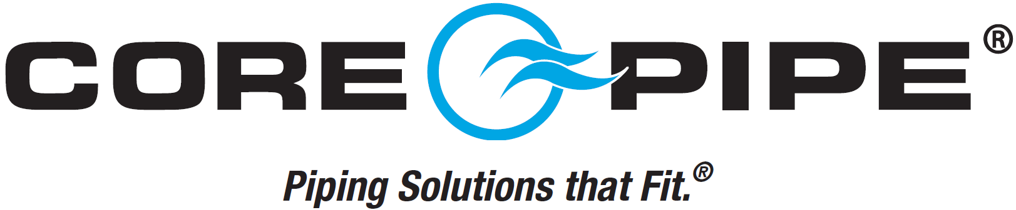

Core Pipe Products, Inc., Carol Stream, IL, is one of the premier manufacturers of stainless and alloy pipe fittings and flanges in the world. The company has earned this reputation through the hard work and dedication of their employees who are truly the most valued asset.
We are looking for team members with great attitudes, a can-do work ethic, and a willingness to learn to join us at either of our US locations.
Inside Sales Representative – Full Time Hours: 8:00AM – 5:00PM M-F
Essential Job Functions:
- Generate revenue in your sales region
- Strengthen relationships with customers
- Service customer accounts and provide quotes
- Receive and place phone calls to explore customer needs
- Collaborate with management to ensure competitive pricing
__________________________________________________________________________________________________
Packer/Material Mover – Full Time Hours: 8:00AM – 4:30PM M-F
Essential Job Functions:
- Perform standard shipping operations – packing and making boxes
- Boxing stainless steel parts for inventory
- Loading and unloading trucks & inventory via forklift
  - Core Pipe will train and certify employee for forklift operation

Maintenance Mechanic – Full Time Hours: 7:00AM – 3:30PM M-Th
6:00AM – 2:30PM Friday Essential Job Functions:
- Keep all production machines in operational condition
- Perform repairs on hydraulic, mechanical, and electrical components, as well as building utilities
- Repair experience on CNC lathes preferred
- Hydraulics & PLC (programmable logic control) experience/troubleshooting preferred
- Perform building maintenance duties

Unskilled labor positions are available. Core Pipe will provide training. Select “Laborer” when applying online.
See other side
CNC Programmer – Full Time Hours: 8:00AM – 4:30PM M-F
Essential Job Functions:
- Program and set up CNC’s and machining centers
- Fixture and program all jobs given
__________________________________________________________________________________________
Beveler Machine Operator – Full Time Hours: 6:00AM – 4:30PM M-Th
Essential Job Functions:
- Set up and operate beveling machine according to production needs/specifications
- Need light math skills

What You Receive:
Competitive Compensation & benefits package
Exciting career opportunity in a recession-resistant industry
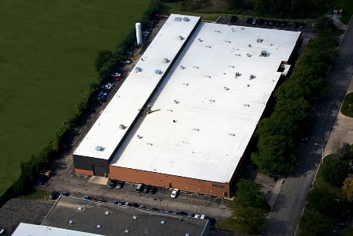
Get to know Core Pipe
- Manufacturer of stainless steel and alloy pipe fittings/flanges.
- Two domestic facilities: Carol Stream, IL, and Sanford FL.
- Founded in 1978.
- 91 employees between both locations.
Carol Stream, IL
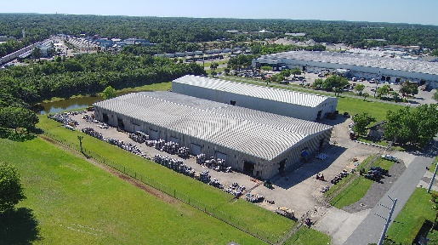
Some of the products we manufacture:
Elbows
Flanges
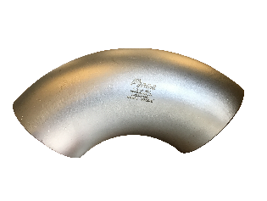
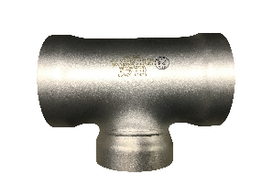
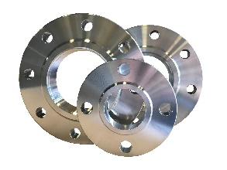
Tees
Sanford, FL

Equal Opportunity Employer (EOE) | Visit www.CorePipe.com/careers to apply today!
Company Information:
Core Pipe Products, Inc.
170 Tubeway Drive
Carol Stream, IL 60188
630-690-7000
www.CorePipe.com

